SAFETY DATA SHEET
SECTION 1: Identification
Product Identifier: ON12
Manufacturer’s Address:
Southern Organics & Supply, Inc.
4813 East Fork Lane,
Monroe, NC 28110
Manufacturer’s Phone Number:
(704) 283-2457
Emergency Phone Number:
911
Recommended Use: As a soil amendment.

SECTION 2: Hazard Identification
Acute Toxicity, Oral – Category 5 | 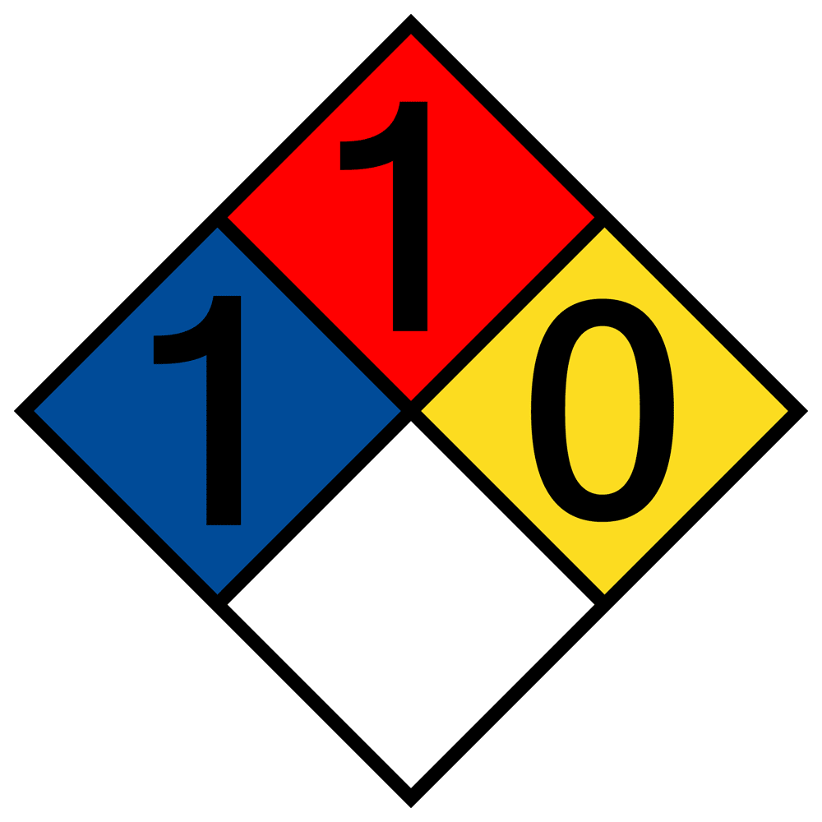
Signal Word: Warning
Pictograms
Hazard Statements
H303: May be harmful if swallowed.
Precautionary Statements
P102: Keep out of reach of children.
P103: Read label before use.
P312: Call a POISON CENTER or doctor/physician if you feel unwell.

SECTION 3: Composition Information
Trade Secret | 100%
Total | 100%

SECTION 4: First-Aid Measures
INHALATION: Remove to fresh air immediately. If victim is not breathing, give artificial respiration. If symptoms develop, seek medical attention.
SKIN CONTACT: Flush skin thoroughly with clean water. If irritation occurs, seek medical attention.
EYE CONTACT: Remove contact lenses. Flush affected eye(s) continuously for 15 minutes with clean water. If irritation or other symptoms develop, seek medical attention.
INGESTION: Drink plenty of water. Do not induce vomiting. Seek medical attention. Never give anything by mouth to an unconscious/unresponsive person.
Symptoms of Exposure
Skin contact may produce skin irritation. Eye contact may produce eye irritation. Ingestion may be harmful.
Recommendations for Immediate Medical Care
Remove all residual material if possible. Product is likely to contain naturally-occurring microorganisms, so any exposed wounds or mucous membranes should be decontaminated appropriately.

SECTION 5: Fire-Fighting Measures
Suitable Extinguishing Media: Water spray, dry chemical, CO₂, foam
Specific Hazards Arising from this Substance: If ignited, product may smolder in piles or bags, even after surface fires have been extinguished. Bags should be broken and material spread out to ensure all fire is extinguished. Product may generate flammable dust under certain circumstances.
Recommendations for Firefighter Protective Equipment: Firefighters should wear self-contained breathing apparatus, operated in positive-pressure mode, as well as appropriate protective clothing.

SECTION 6: Accidental Release Measures
Personal Precautions: Wear gloves, work clothes, and eye protection. If dust is generated, NIOSH-approved respirator should be worn.
Emergency Procedures: Non-essential personnel should be evacuated from spill area.
Methods of Containment: Contain spill with a physical barrier.
Cleanup Procedures: Spilled material may be swept, raked, or shoveled into an appropriate disposal container. Spilled material should be disposed of as organic waste, in accordance with local, state, and federal laws.

SECTION 7: Handling and Storage
Precautions for Safe Handling: Protect open wounds from contact with product. Avoid splashing.
Conditions for Safe Storage, Including Incompatibilities: Store indoors at ambient temperature. Store in original container. Keep away from children and pets. Store below 120°F where possible.
Further Information: Use good personal hygiene practices. This substance is made from natural products, and may contain naturally-occurring microorganisms. Take proper precautions to avoid infection of open wounds, and eye irritation. Hygiene practices necessary to prevent health hazards from natural substances such as soil should be observed. After handling product, hands should be washed with soap and water before eating, drinking, smoking, or using toilet facilities.

SECTION 8: Exposure Controls / Personal Protection
OSHA PEL  NDA | ACGIH  NDA | TLV  NDA | Other Exposure Limits  NDA
Engineering Measures: Store indoors at ambient temperature.
Eye Protection: Safety glasses or safety goggles should be worn where eye exposure is likely.
Hand Protection: Not required, but any appropriate work gloves may be worn if desired.
Skin and Body Protection: Normal work clothing.
Respiratory Protection: If dust is generated, NIOSH-approved respirator should be worn.
General Protective and Hygiene Practices: Appropriate local ventilation, where required. Open wounds should be kept clean and protected. After handling material, wash hands before eating, drinking, smoking, or using restrooms. Keep away from foodstuffs and beverages.

SECTION 9: Physical and Chemical Properties
Physical State: Solid
Appearance: Brownish powder.
Odor: None.
Odor Threshold: NDA
pH: NDA
Melting/Freezing Point: NDA
Boiling Point/Range: NDA
Flash Point: NDA
Evaporation Rate: NDA
Flammability (solid, gas): NDA
Flammability or explosive limits:
Upper: NDA
Lower: NDA
Vapor Pressure: NDA
Relative Density: NDA
Solubility: NDA
Partition coefficient; n-octanol/water: NDA
Autoignition Temperature: NDA
Decomposition Temperature: NDA
Viscosity: Solid.

SECTION 10: Stability and Reactivity
Reactivity: Inert.
Stability: Stable under normal conditions.
Conditions to Avoid: Keep away from open flames, hot surfaces, and sources of ignition.
Incompatible Materials: Strong acids, strong bases, strong oxidizers, strong reducing agents.
Hazardous Decomposition Products: CO₂ (carbon dioxide). CO (carbon monoxide).

SECTION 11: Toxicological Information
Likely Routes of Exposure: Possible routes of exposure include eye contact, skin contact, or ingestion.
Effects of Exposure: NDA
LD₅₀: NDA
Description of Symptoms: NDA
NTP/IARC Carcinogenicity: NDA

SECTION 12: Ecological Information
Ecotoxicity: NDA
Biodegradation: Product is a natural material, and will biodegrade.
Octanol-Water Partition Coefficient: NDA
Bioconcentration Factor: NDA
Other Adverse Effects: None.

SECTION 13: Disposal Considerations
For safe handling practices, see Section 8.
Disposal Containers: Material should be disposed of in its original container, where possible. If original container is not available, material may be disposed of in any container suitable for granular organic material.
Disposal Methods: Material may be disposed of as organic waste, according to state, local, and federal laws.
Properties Affecting Disposal: If material is treated with any chemical agents prior to disposal, the disposal guidelines in the treating chemical’s Safety Data Sheet should be followed.
Special Precautions for Landfill or Incinerator Disposal: None.
Do not dispose of waste product in sewers, storm drains, lakes, ponds, streams, or other bodies of water.

SECTION 14: Transport Information
UN Number: Unknown
UN Proper Shipping Name: ON12
Transport Hazard Class(es): None
Packing Group Number: N/A
Environmental Hazard(s): None
Guidance on Transport in Bulk: Product may shift or settle during shipping.
Special Precautions: None.

SECTION 15: Regulatory Information
No special regulatory information.

SECTION 16: Other Information
Date Prepared: August 15, 2017
Last Revision: May 25, 2018
Prepared By: Matthew Banks, Chief Science Officer
Preparer Contact Information:
PO Box 2099,
Indian Trail, NC 28279
Ph: (704) 283-2457
Fx: (704) 283-2104
E-mail: vermaplex@live.com
(NDA = No Data Available)
NOTE: The information and recommendations contained herein are based upon data which is believed to be correct. However, no guarantee or warranty, expressed or implied, is offered with respect to the information contained herein. This Safety Data Sheet was prepared to comply with the OSHA Hazard Communication standard (29 CFR 1910.1200). This supersedes any previous Safety Data Sheets, and any information therein. Since the actual use of the product is beyond the control of Southern Organics & Supply, Inc., Southern Organics & Supply, Inc., makes no guarantee, expressed or implied, as to the effects of such use, nor does Southern Organics & Supply, Inc. assume any liability arising from use of the products referenced herein. Nor is the information herein to be construed as absolutely complete, since additional information may be necessary or desirable under some circumstances. All SDS's are reviewed every 3 years, or sooner, if necessary. Please check the date last revised in Section 16. Please request a new SDS from Southern Organics & Supply if this date is more than 3 years ago. If clarification is required or desired, please contact the company official(s) listed in Section 1.

